

BEKA VAPOURLINE

Technical Product Specifications

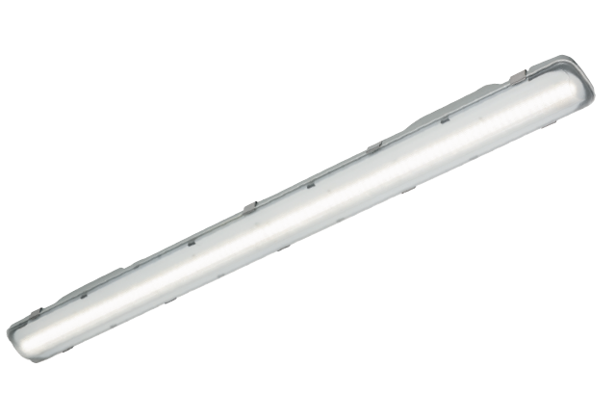

Table of contents

1. General Specifications 3
2. Photometry 4
3. Mechanics 5
4. Electrical Characteristics 6
5. Power Supply 7
6. Environment 7

- General Specifications

Product Description | The Vapourline (VLN) luminaire consists of an injection-moulded, flame-retardant polycarbonate housing and prismatic diffuser.  The powder coated white LED plate in the 4ft is secured into the diffuser that also houses the motion sensor; all other electrical components are mounted inside the housing, the diffuser clips securely onto the housing.  The silicon sponge seal is moulded into the housing to ensure an optimal seal between the housing and the diffuser.  A suspension hanger is provided to allow the easy installation of the fitting.  It is designed to operate LEDs of up to 49W.  The luminaire shall bear the SANS 60598-2-1 safety mark.  The luminaire shall have a degree of protection that complies with SANS 60598-2-1:  LED compartment: IP 65  The IP rating is supported by a certified SABS test report.  The LED engine, consisting of the LED light source and the power supply. To maximize the reliability of the LED’s, the photometrical engine is completely sealed to IP 65. This ensures that the photometric performance is maintained over time. The IP65 rating is ensured by means of a silicon sponge gasket fixed into a groove to seal.  The high-impact polycarbonate protector allows for impact resistance of IK 08.  All control gear components are removable and bear the relevant Quality mark. All internal wiring are Teflon® coated to prevent damage by possible abrasion.  The closing clips and all screws and metal parts are stainless steel or non-corrosive material. Mains connections by means of a suitable screw terminal block with a wire clamping contact. The luminaire power factor corrected to a minimum of 0,95.  The IP 65 LED housing compartment optimizes the thermal operating environment around the LEDs enabling the long useful lifetime (60 000hrs, L70). With the introduction of LED technology Dimming options are much easier and further maximize energy savings.
Main applications | - Industry  - Corrosive environments  - Mining  - Damp environments  - Public buildings  - Parking Garages
Recommended mounting height | 2m - 5m

- Photometry

Light source | LED
LED | Midpower
Light colour | 4000K (Neutral white 840)  5700K (Cool white 857) (optional)
Colour rendering (Ra) | ≥80 (Neutral white 840)  ≥ 80 (Cool white 857) (optional)
Lumen package  27W  41W  49W | 4577lm  7122lm  8170lm
Optics | Symmetric
Photometry: | 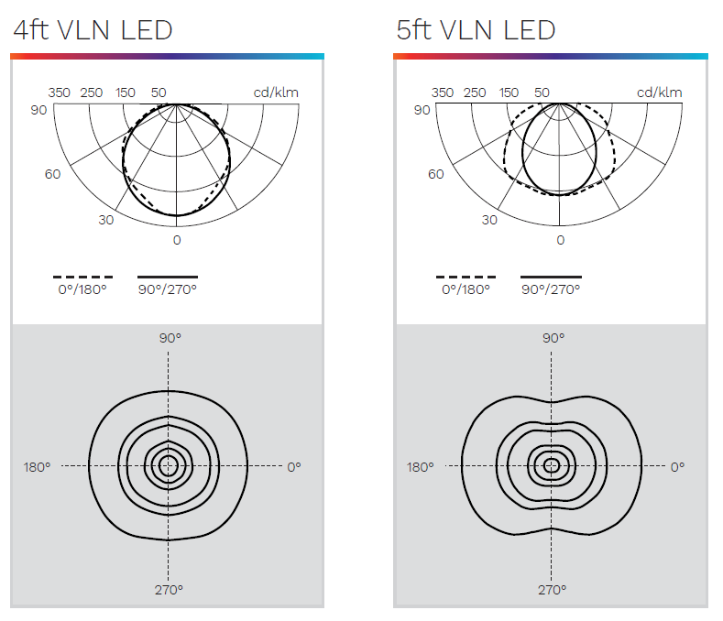

Description | LED Current | Lumen* | Lifetime Residual Flux @ tq 25°C
Description | LED Current | Lumen* | @60 000h
BEKA VLN 27W  BEKA VLN 41W  BEKA VLN 49W | 250mA  300mA  400mA | 4577  7122  8170 | 70%

(*) The type of LED used is subject to change due to the ongoing rapid progress taking place in LED technology

- Mechanics

Electronic control Gear | Constant Current LED Driver
Materials and finishing | Housing – High-impact Polycarbonate  Protector – High-impact Polycarbonate
Coating | Light grey Polypropylene
Installation | Mounting clips
Fixing | Stainless steel mounting clips  Mounting clips with suspension triangle
Dimensions (LxWxH) | 4ft: 1165 x 97 x 92*  5ft: 1573 x 101 x 101*  *STD version
Weight (with gear) | 4ft: 2.1kg*  5ft: 2.5kg*  *STD version
Access | Yes
Aerodynamic resistance (CxS): | N/A

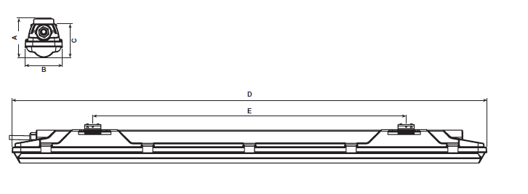
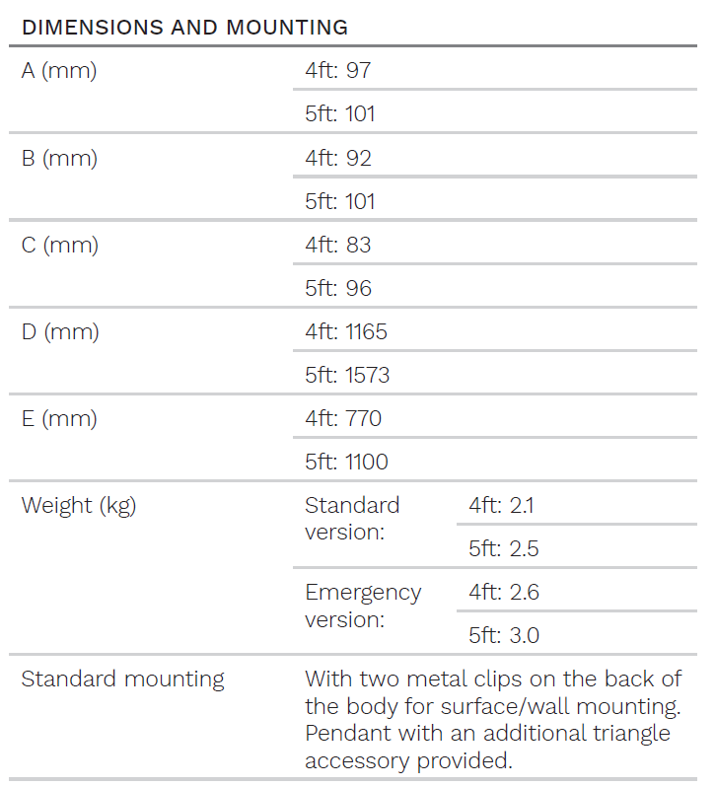

- Electrical Characteristics
Line Voltage | 230VAC
Mains voltage Tolerance (AC) | 198-264V
Line frequency | 50Hz
Electrical Safety Class (IEC) | Class I
Surge protection | 10kV/10kA
Lighting control | Optional: DALI  Movement sensor

- Power Supply
Power Factor | ≥0.95
Removable | Yes

- Environment

Operating temperature | Standard version: -35 < T < 40deg C  Emergency version: -35 < T < 35deg C
Enclosure Tightness | IP 65
Enclosure Mechanical Withstand Impact | Polycarbonate – IK 08
Enclosure Mechanical Withstand Vibrations | Modified IEC 60068-2-6
Explosion proof | Zone 21/22 – (optional)⁽¹⁾  Zone 2 – (optional)⁽¹⁾  ⁽¹⁾ Only available for the 30W & 41W versions

Updated by | Approved by | Document Revision / Date
Nadja Smith | Pieter van Aardt | 13/02/2024

- For specific T_{q}, T_{a} and lifetime data, contact BEKA Schréder

