

LEDlume XP

Technical Product Specifications

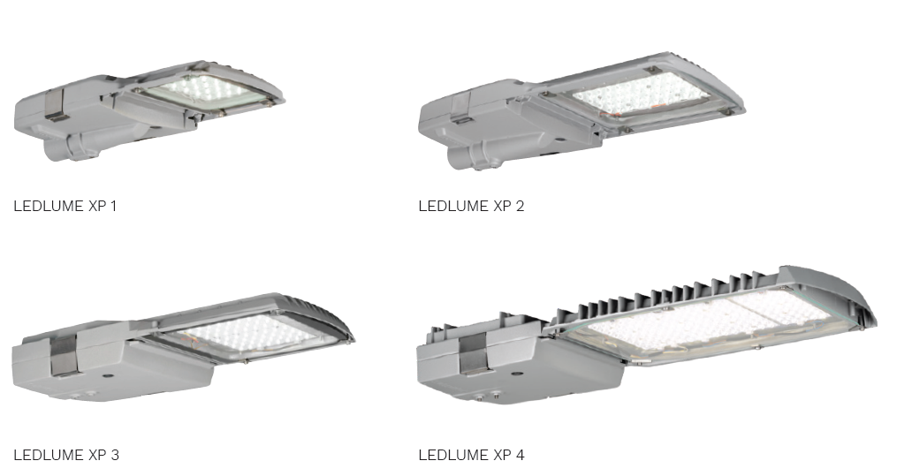

Table of contents

1. General Specifications 3
2. Photometry 5
3. Mechanics 8
4. Electrical Characteristics 9
5. Power Supply 10
6. Environment 10

- General Specifications

Product Description | Side entry luminaire designed for optimized residential road, roads & motorways, car parks, pedestrian and perimeter lighting.  The luminaire consists of a spigot base compartment and hinged LED engine top casting. This hinged design allows the easy installation of the LED engine and the stainless steel latches allows for easy closure achieving the IP 66 water ingress protection of the electronic components. The design can operate LEDs of up to 265W. The mains terminal connector enclosed inside a cavity on the spigot base for improved water ingress.  The luminaire shall bear the SANS 60598-2-3 safety mark.  The luminaire shall have a degree of protection that complies with SANS 60598-2-3:  LED compartment: IP 66  The IP rating is supported by a certified SABS test report.  The LED engine, consisting of the LED light source and the power supply, can be easily replaced or upgraded. To maximize the reliability of the LED’s, the photometrical engine is completely sealed to IP 66. This ensures that the photometric performance is maintained over time.  Electronic temperature monitoring prevents overheating of LED’s and power supply.  The spigot base casting easily slides onto a 42mm outreach and secures with 2 M8 grub screws. The two stainless steel latches make for easy tool free maintenance. It has a blade connector that allows for electrical disconnection as soon as the luminaire is opened.  Manufactured from marine grade aluminium allows for corrosion resistance and optimal thermal management. A silicon sponge gasket fixed into a groove seals the spigot base casting to the LED engine casting to IP 66.  The high-impact clear glass protector allows for impact resistance of up to IK 09 with the option of Polycarbonate protector with an impact resistance of IK 10.  All LED’s have individual lenses for optimal light distribution for improved light performance. Additional anti-glare louvres and back light control is available.  All control gear components are removable and bear the relevant SABS mark. All internal wiring are Teflon® coated to prevent damage by possible abrasion.  All screws, bolts and metal parts are stainless steel or non-corrosive material. Mains connections by means of a suitable screw terminal block with a wire clamping contact. The luminaire power factor corrected to a minimum of 0,9.  The IP 66 LED housing compartment optimizes the thermal operating environment around the LEDs enabling the long useful lifetime (100 000hrs, L95B10). With the introduction of LED technology, dimming options are much easier and further maximize energy savings.
Main applications | - Road lighting & Motorways  - Squares & Pedestrian area lighting  - Security perimeter lighting  - Parking areas  - Bike & Pedestrian Paths
Recommended mounting height | 4m - 30m

- Photometry

Light source | LED
LED | 2mm² LED
Light color | 4000K (Neutral white 740)  3000K (Warm white 730) – optional  5700K (Cool white 757) – optional
Color rendering (Ra) | ≥70
Power consumption  12W  17W  23W  35W  23W  32W  45W  54W  69W  33W  47W  66W  96W  43W  61W  88W  100W  55W  78W  111W  65W  93W  111W  131W  84W  122W  147W  151W  217W  179W  257W  209W  254W  239W  265W | Nominal Lumen package  1905lm  2576lm  3395lm  4501lm  3810lm  5109lm  6790lm  7864lm  9002lm  5714lm  7729lm  10281lm  13650lm  7560lm  10131lm  13452lm  14969lm  9226lm  12555lm  16814lm  11071lm  15066lm  17622lm  20177lm  14761lm  20088lm  23496lm  25110lm  33629lm  30132lm  40355lm  35154lm  41117lm  40176lm  43584lm
Optics | Asymmetric
Photometry: | 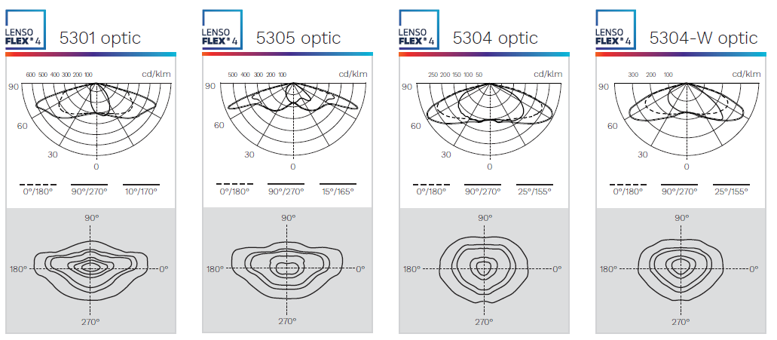  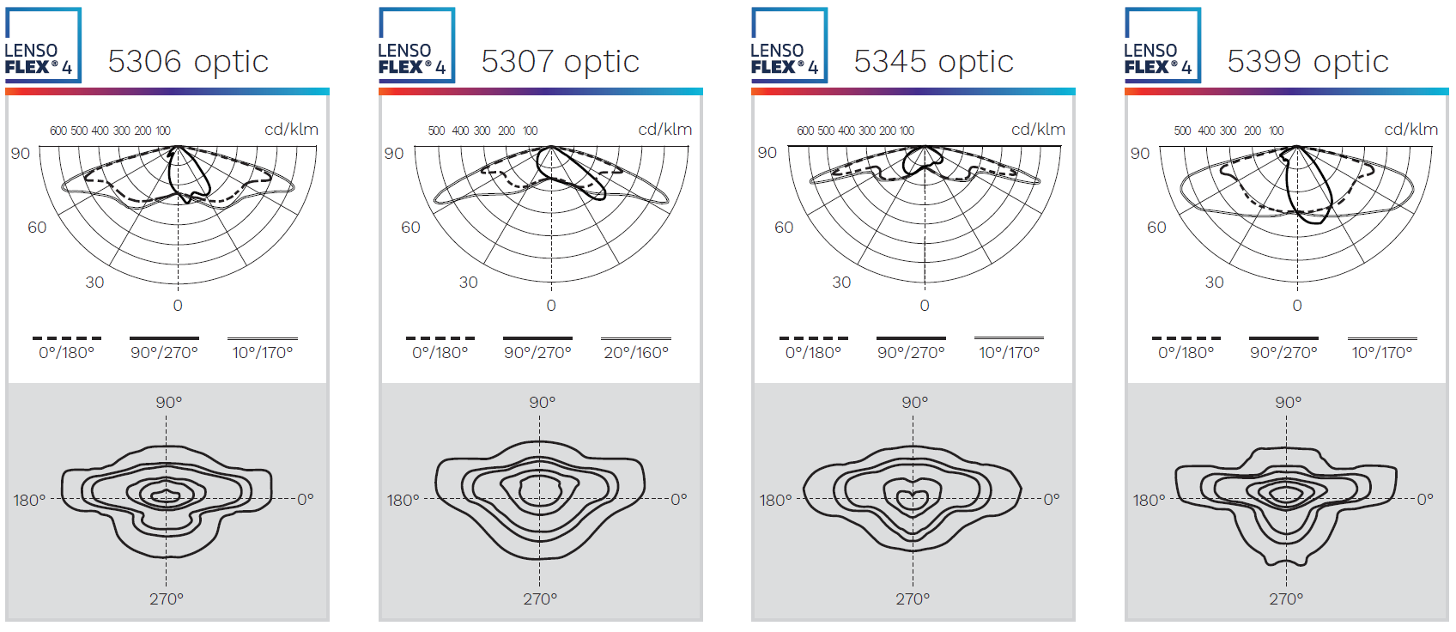  Please note: Optic 5304-W only applicable to 40 LED, 80 LED, 120 LED and 160 LED versions

Description | LED Current | LED | Nominal Lumen* | Lifetime Residual Flux @ tq 25°C
 |  |  |  | @100 000h
LEDlume XP 1 12W | 350mA | 10 | 1905 | 95%
LEDlume XP 1 17W | 500mA | 10 | 2576 | 95%
LEDlume XP 1 23W | 700mA | 10 | 3395 | 95%
LEDlume XP 1 35W | 1000mA | 10 | 4501 | 95%
LEDlume XP 1 23W | 350mA | 20 | 3810 | 95%
LEDlume XP 1 32W | 500mA | 20 | 5109 | 95%
LEDlume XP 1 45W | 700mA | 20 | 6790 | 95%
LEDlume XP 1 54W | 850mA | 20 | 7864 | 95%
LEDlume XP 1 69W | 1000mA | 20 | 9002 | 95%
LEDlume XP 2 33W | 350mA | 30 | 5714 | 95%
LEDlume XP 2 47W | 500mA | 30 | 7729 | 95%
LEDlume XP 2 66W | 700mA | 30 | 10281 | 95%
LEDlume XP 2 96W | 1000mA | 30 | 13650 | 95%
LEDlume XP 2 43W | 350mA | 40 | 7560 | 95%
LEDlume XP 2 61W | 500mA | 40 | 10131 | 95%
LEDlume XP 2 88W  LEDlume XP 2 100W | 700mA  800mA | 40  40 | 13452  14969 | 95%
LEDlume XP 3 55W | 350mA | 50 | 9226
LEDlume XP 3 78W | 500mA | 50 | 12555 | 95%
LEDlume XP 3 111W | 700mA | 50 | 16814 | 95%
LEDLUME XP 3 65w  LEDLUME XP 3 93W  LEDLUME XP 3 111W  LEDLUME XP 3 131W | 350mA  500mA  600mA  700mA | 60  60  60  60 | 11071  15066  17622  20177 | 95%
LEDLUME XP 3 84w  LEDLUME XP 3 122W  LEDLUME XP 3 147W | 350mA  500mA  600mA | 80  80  80 | 14761  20088  23496 | 95%
LEDLUME XP 4 151W  LEDLUME XP 4 217W | 500mA  700mA | 100  100 | 25110  33629 | 95%
LEDLUME XP 4 179W  LEDLUME XP 4 257W | 500mA  700mA | 120  120 | 30132  40355 | 95%
LEDLUME XP 4 209W  LEDLUME XP 4 254W | 500mA  600mA | 140  140 | 35154  41117 | 95%
LEDLUME XP 4 239W  LEDLUME XP 4 265W | 500mA  550mA | 160  160 | 40176  43584 | 95%
(*) The type of LED used is subject to change due to the ongoing rapid progress taking place in LED technology

- Mechanics

Electronic control Gear | Constant Current LED Driver IP 66
Materials and finishing | Spigot base casting – Marine grade aluminium (EN 1706 AC-44300)  LED Engine – Marine grade aluminium  Protector – High-impact clear glass
Coating | Unpainted aluminium  RAL colours on request
Installation | Side Entry Pole Mount
Fixing | Side Entry Pole Mount – 2 x M8 grub screws
Dimensions (LxWxH) (mm) | XP 1: 444 x 244 x 104*  XP 2: 535 x 244 x 107*  XP 3: 618 x 345 x 111*  XP 4: 386 x 835 x 120*  *STD version
Weight (with gear) | XP 1: 4kg  XP 2: 4.5kg  XP 3: 9kg  XP 4: 13kg
Access | Yes
Aerodynamic resistance (CxS): | XP 1: 0.046m²  XP 2: 0.057m²  XP 3: 0.072m²  XP 4: 0.088m²

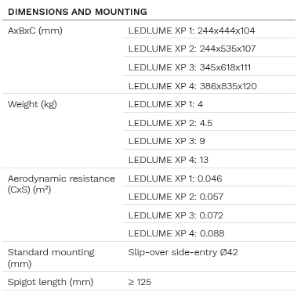

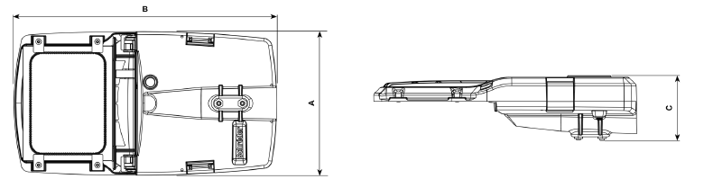

- Electrical Characteristics
Line Voltage | 230VAC
Mains voltage Tolerance (AC) | 198-264V
Line frequency | 50Hz
Electrical Safety Class (IEC) | Class I or II
Surge protection | 10kV/10kA  20kV/20kA - optional
Lighting control | Optional - NEMA 3-pin socket only  - - NEMA 7-pin socket only  - NEMA with Royce Thomson DLS  - NEMA with Spectrum DLS  - NEMA 3-pin with dummy link  - NEMA 7-pin with plug-in 20kV surge  - Schréder EXEDRA CM  - DIM (Optidim)  - DIM Profile (1-5)

- Power Supply
Power Factor | ≥0.95
Removable | Yes
Thermal Safety | Yes

- Environment

Storage temperature  Operating temperature | -20°C up to 35ºC  -35°C up to +40°C
Enclosure Tightness | IP 66
Enclosure Mechanical Withstand Impact | Glass:  XP 1 & XP 2: IK 08  XP 3 & XP 4: IK 09  Polycarbonate: IK 10
Enclosure Mechanical Withstand Vibrations | Modified IEC 60068-2-6

Updated by | Approved by | Document Revision / Date
Nadja Smith | Pieter Van Aardt | 07/11/2023

- For specific T_{q}, T_{a} and lifetime data, contact BEKA Schréder

