

OMNIstar-MIDI

Technical Product Specifications

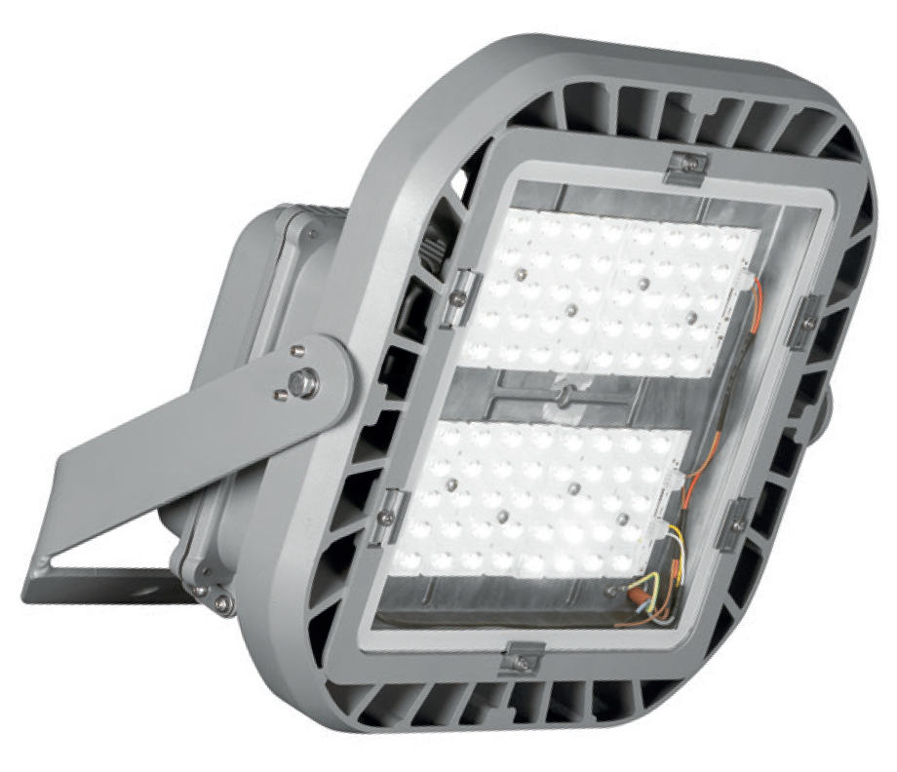

Table of contents

1. General Specifications 3
2. Photometry 4
3. Mechanics 6
4. Electrical Characteristics 8
5. Power Supply 8
6. Environment 9

- General Specifications

Product Description | The OMNISTAR has been designed to provide an unrivalled combination of performance and flexibility for lighting areas where high lumen packages are needed while offering maximum savings in energy and maintenance costs with a short payback time. This luminaire can be installed in various applications to provide the lighting distribution and lumen package needed to meet the specifications of the area to be lit.  The OMNISTAR guarantees optimal lighting to ensure safety and comfort. It offers a real alternative to luminaires equipped with traditional sources, with the added advantages of an LED solution: low energy consumption, improved visibility with white light, limited maintenance, and longer life.  The OMNISTAR is adaptable to all floodlighting applications to ensure maximum energy savings by adapting the light levels according to the needs.  A wide range of photometry is available. The LensoFlex® photometric engine allows flexibility of multiple light distributions to ensure that the specific requirements of each application are met.  ThermiX®: The OMNIstar offers an efficient thermal management of both the LEDs and the power supply thanks to the separation between the optical unit and the gear box. The cooling fins on the optical unit optimize the heat dissipation. This design enables the OMNIstar to perfectly manage high ambient temperatures (T_{a} up to 55°C) and ensures reliability in the long term.  The luminaire housing is manufactured of high-pressure die-cast aluminum. To withstand even the most corrosive environments, the luminaire housing is especially e-coated (optional).  This luminaire is available for emergency lighting, Zone 2 and 21/22 applications.  It is designed for LED light sources between 136W and 226W.
Main applications | - Industrial Areas - Highbay Industrial Warehouses  - Indoor Sports: Swimming pools, Gymnasium, Action Cricket, Soccer and Netball venues  - Outdoor Sport: Tennis Courts, Hockey Fields  - Transport hubs (airport aprons, harbours, bus stations and train stations)  - Streetlighting - large highway intersections, toll plazas  - Area Lighting
Recommended mounting height | 8 - 30m

- Photometry

Light source | LED
LED | 2mm² or 4mm² LED
Colour Temperature | 4000K (Neutral white 740)  5700K (Cool white 757) (optional)
Colour rendering (Ra) | ≥ 70 (Neutral white 740)  ≥ 70 (Cool white 757) (optional)
LEDs / Wattage  60 LED @ 700mA 136W  to  80 LEDs @900mA 226W | Lumen Package  20013lm  to  32044lm
Optics | LensoFlex®4:  5304, 5304-W, 5355, 5356, 5366, 5405, 5407  BlastFlexTM4:  5357, 5357-W, 5358, 5359
Photometry: | 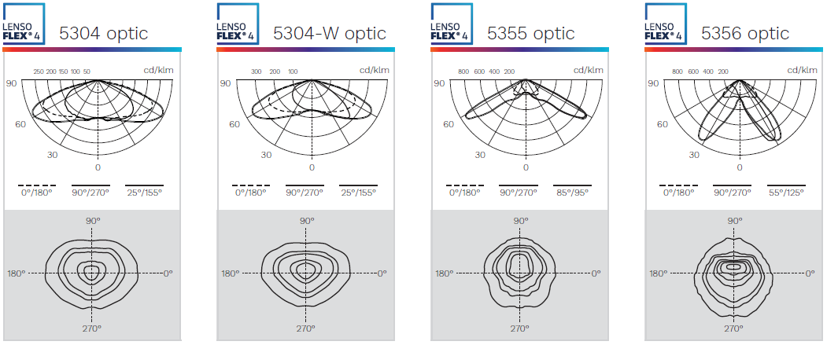  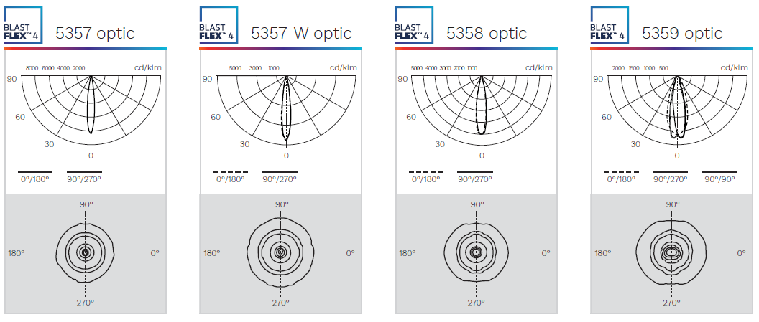  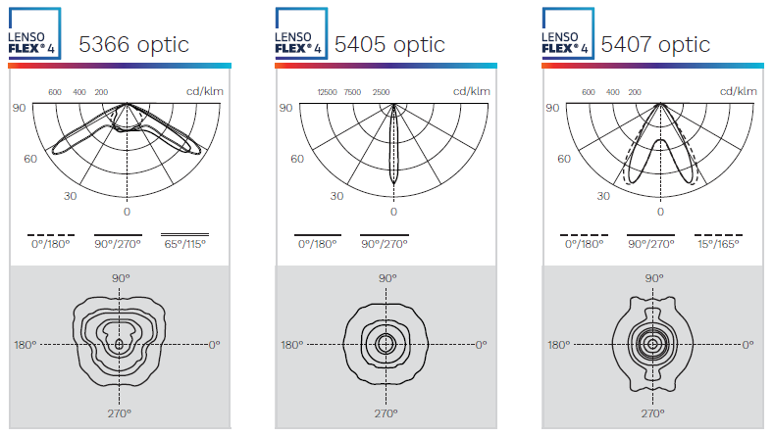

 |  |  |  | Lifetime residual flux T_{q} 25⁰C
Number of LEDs | Neutral white (4000K) | 60 LEDs | 80 LEDs | 100.000h  90%
Current 700mA | Nominal Flux (lm) ⁽¹⁾ | 20013 | - | 100.000h  90%
Current 700mA | Power Consumption (W) | 136 | - | 100.000h  90%
Current 850mA | Nominal Flux (lm) ⁽¹⁾ | - | 30043 | 100.000h  90%
Current 850mA | Power Consumption (W) | - | 212 | 100.000h  90%
Current 900mA | Nominal Flux (lm) ⁽¹⁾ | - | 32044 | 100.000h  90%
Current 900mA | Power Consumption (W) | - | 226 | 100.000h  90%
Current 1000mA | Nominal Flux (lm) ⁽¹⁾ | 25535 | - | 100.000h  90%
Current 1000mA | Power Consumption (W) | 190 | - | 100.000h  90%

⁽¹⁾ The nominal flux is an indicative LED flux @ Ts 85°C based on LED manufacturer’s data. The real flux output of the luminaire depends on environmental conditions (e.g. temperature and pollution) and the optical efficiency of luminaire. The type of LED used is subject to change due to the ongoing rapid progress taking place in LED technology.

- Mechanics

Electronic control Gear | Constant Current Driver
Materials and finishing | Housing  Unpainted aluminium  Protector – High Impact Clear Glass  Optional: High-impact polycarbonate
Finish | Standard Pearl Light Grey (RAL 9022), Textured finish  Optional: Any other RAL colour available on request
Installation | Standard: Stirrup version  Optional:  Suspended version  U-bracket
Fixing | 2 x ø 8mm bolts (standard version)  4 x ø 6mm eyebolts (suspended version)
Weight (with gear) | Up to 10.8kg
Access | Yes
Aerodynamic resistance | 0.12m²

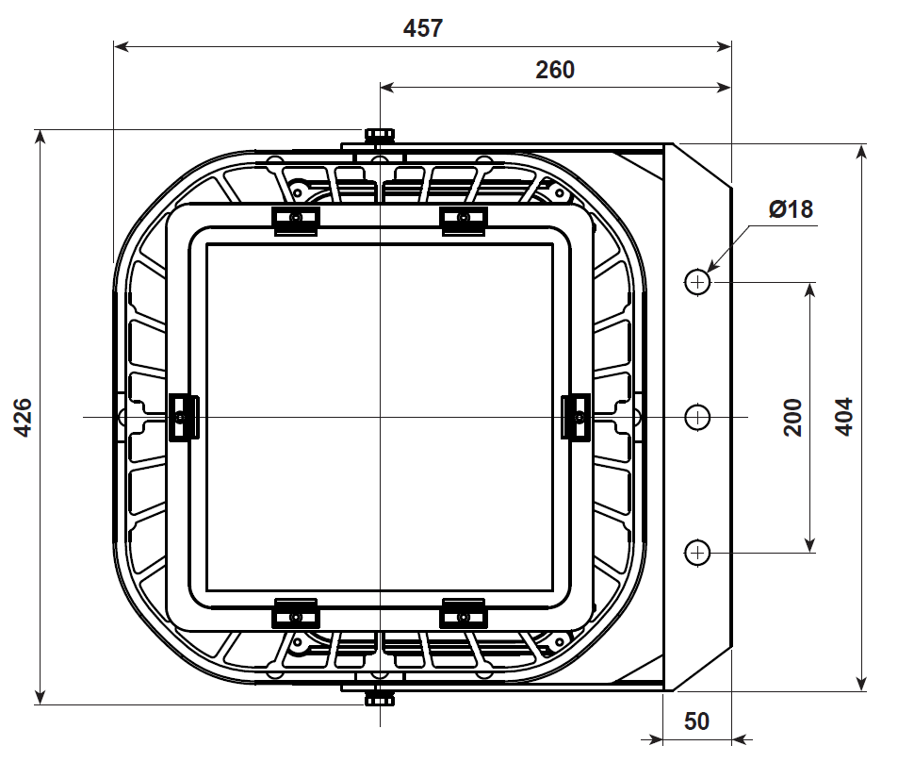
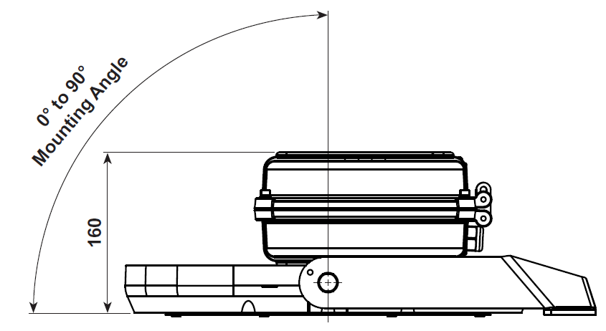

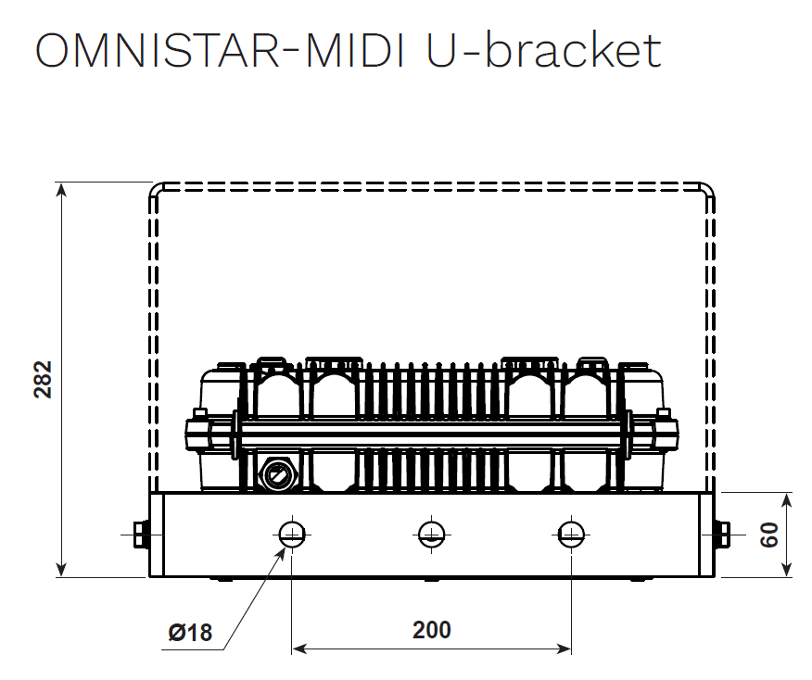

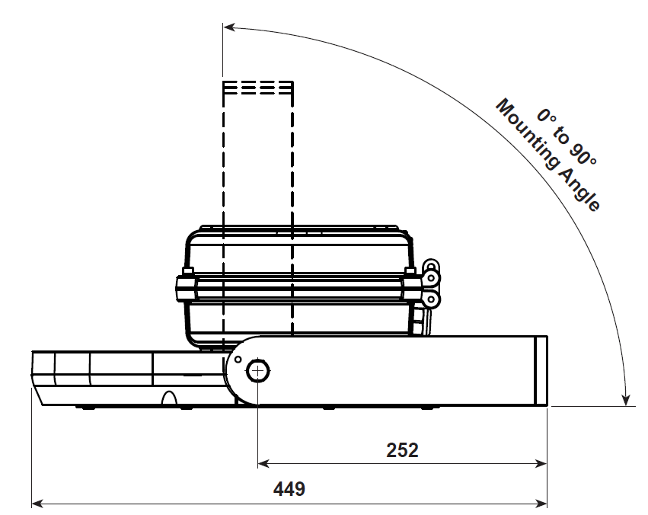

- Electrical Characteristics
Line Voltage | 230VAC
Mains voltage Tolerance (AC) | 198-264V
Line frequency | 50Hz
Electrical Safety Class (IEC) | Class I
Surge protection | Yes - 10kV/10kA  Optional - 20kV/20kA
Lighting control | Optional:  - 1-10V  - DALI  - Schréder ITERRA  - Schréder EXEDRA remote management  - 3-pin NEMA  - 7-pin NEMA

- Power Supply
Power Factor | ≥0.95
Removable | Yes
Thermal Safety | Yes

- Environment

Storage temperature | - 40⁰C to +60⁰C
Operating temperature (T_{a}) | - 40⁰C to + 50⁰C
Enclosure Tightness | IP 66
Enclosure Mechanical Withstand Impact | Up to IK 10

* Certified Test Standard SANS IEC 60598 -2-5 (available on request)

Updated By: | Approved by | Document Revision / Date
Nadja Smith | Pieter van Aardt | 05/04/2023

- For specific Tq, Ta and lifetime data, contact BEKA Schréder

