Series 40

Technical Product Specifications

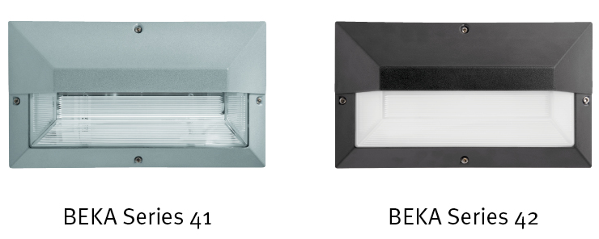

Table of contents

1. General Specifications 3
2. Photometry 3
3. Mechanics 4
4. Electrical Characteristics 4
5. Power Supply 5
6. Environment 6

- General Specifications

Product Description | The luminaire base and trim ring is manufactured of a high-pressure die-cast marine grade aluminium (EN 1706 AC-44300). The trim ring casting is mounted onto the base casting by means of stainless steel M5 Allen head screws, located outside the lamp compartment. The base and trim are finished with epoxy powder coating.  A clear prismatic or opal non-discolouring high impact acrylic injection moulded diffuser is used throughout the range. It shall offer excellent vandal resistance, be highly translucent and shall not discolour even when subjected to the harshest UV environments. A silicon sponge gasket shall be fitted into a special groove in the diffuser to prevent damage to the gasket during installation and to achieve the certified ingress protection rating of IP 65. It shall be designed to operate LEDs of 1095lm (8W). The luminaire shall be supplied with a 300mm supply lead.
Main applications | - Commercial Developments  - Retail Areas  - Shopping malls  - Public buildings

- Photometry

Light source | Light Emitting Diode
LED | LED Module
Colour temperature | LED: Neutral White (4000K)  Optional : Warm White (3000K)
Colour rendering (Ra) | ≥80
LED | Up to 1095lm  * see table below
Optics | Asymmetrical
Photometry: | 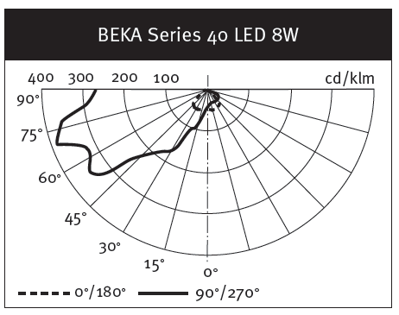

Light Source | Line Current (A) | LUMEN
LED 8W | 0.03 | 1095*

(*) The type of LED used is subject to change due to the ongoing rapid progress taking place in LED technology

- Mechanics

Materials and finishing | Base – High-pressure die-cast marine grade …. aluminium (EN 1706 AC-44300)  Diffuser – High impact Acrylic (IK08)
Finish | Black - RAL9017 textured finish (Standard)  White - RAL9003 textured finish  Optional : other RAL colours available on request
Diffuser | Opal non-discolouring high impact acrylic injection molded diffuser.
Fixing | 4 x Raised mounting holes ø6 mm  (outside lamp compartment)
Dimensions (L*W*H) | 341mm * 195mm * 105mm
Weight (with gear) | Up to 2.5kg
Access | Yes
Optional | The fixing holes can be supplied with stainless steel helicoils inserts to avoid ‘galvanic’ or ‘dissimilar’ metal corrosion.

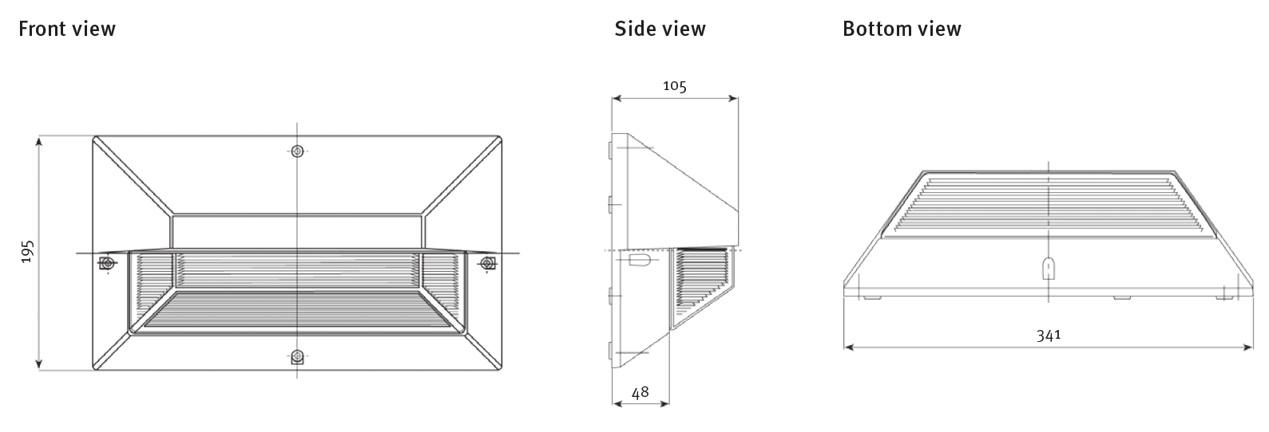
- Electrical Characteristics
Line Voltage | 230VAC
Mains voltage Tolerance (AC) | 198 - 264V
LED: | Constant Current Driver
Line frequency | 50Hz
Electrical Safety Class (IEC) | Class I or II
Surge protection | Yes - 10kV/10kA

- Power Supply
Power Factor | ≥ 0.95
Removable | Yes
Thermal Safety | Yes

- Environment

Storage temperature | - 40⁰C to +60⁰C
Operating temperature (T_{a}) | - 20⁰C to + 35⁰C
Enclosure Tightness | IP 65
Enclosure Mechanical Withstand Impact | IK 08

- * Certified Test Standard SANS IEC 60598 -2-1 (available on request)

Updated by | Approved by | Document Revision / Date
Nadja Smith | Pieter van Aardt | 03/12/2019

- For specific Tq, Ta and lifetime data, contact BEKA Schréder

